Crimson College of Technology

Affiliated to:
Pokhara University
Department of Management

Second Year Project Proposal on
Circuit Bazaar
A Full-Stack Online Marketplace for IT & Electronics Hardware Products

Submitted To
Crimson College of Technology
Devinagar, Butwal

In partial fulfillment of the requirement for the Bachelor in Computer Application/Bachelor of Computer Information System/Bachelor of Computer System and Information Technology.

Submitted by:
Bramha Prasad Tharu (24080709)
Mohammad Aashif Dhobi (24080720)
Rojan Shahi (24080730)
Vihaan Shrestha (24080739)
July, 2026
Abstract
The boom in information technology means that components, networking gear, and accessories have become part of day-to-day needs for students, professionals, gamers, and businesses alike. Here in Nepal, when buyers look to buy IT hardware and accessories, they rely either on walk-in showrooms or buy from general marketplaces where hardware is treated as an add-on with poor specs, inconsistent stock availability and a search engine not suited for the product. We propose Circuit Bazaar, a full stack e-commerce platform where users can browse, compare, and buy IT and electronic hardware (processors, storage, networking gear, accessories and embedded/IoT components) through a swift and specification driven user experience.
Built on the modern, decoupled architecture, the customer facing shop front is powered by Next.js using server-side rendering for performance and SEO, Laravel is used for the secure backend REST API that handles authentication, catalog, orders and payments and MySQL acts as the relational database powering vendor management, product catalogs, user carts and order histories.
Multi-vendor support, detailed category and specification filtering, shopping carts, checkouts and payment integration using payment gateways, order tracking, and an administrator dashboard for managing inventory and users are all supported. Using iterative prototyping and regular feedback from user interactions, Circuit Bazaar intends to provide an accessible and reliable specification-first source for online hardware procurement in Nepal.

TABLE OF CONTENTS

1. Introduction .....................................................................................................................1
1.1 Context and Importance.............................................................................................1
1.2 Problem Statement ....................................................................................................2
2. Objectives .......................................................................................................................3
3. Literature Review ...........................................................................................................3
4. Methodology .…………..................................................................................................6
4.1 Requirement Identification .......................................................................................7
4.1.1 Requirement Analysis ........................................................................................7
4.1.2 Functional Requirements ...................................................................................7
4.1.3 Non-Functional Requirements ...........................................................................8
4.2 Feasibility Study .....................................................................................................10
4.2.1 Gantt Chart .......................................................................................................11
4.3 High-Level Design .................................................................................................11
4.3.1 Flowchart .........................................................................................................13
4.4 Description of Algorithms .....................................................................................14
5. Conclusion ....................................................................................................................15
6. Expected Outcomes ......................................................................................................15
References .........................................................................................................................17

1. Introduction:
Information technology hardware — desktops, laptops, storage, networking devices, peripherals, and the sensors and micro-controller boards used in IoT and embedded projects — form the physical backbone of nearly every digital activity today. With increase in the students in Nepal, it means there is also an increasing number of gaming enthusiasts, freelance developers and courageous entrepreneurs risking their fortunes with small IT businesses in Nepal. This creates the opportunity to develop a quick and reliable avenue to find and shop for IT equipment over the internet. Currently, buying hardware online in Nepal is all over the place; students are searching across social media groups, online e-commerce sites, and individual vendor websites, to get their hands on product specs and prices. But they don’t verify the stock or originality. Circuit Bazaar aims to fill this gap by creating a full-stack e-commerce web app specially designed for buying IT and electronics hardware, where vendors can list products with proper, standardized specifications and buyers can search, filter, compare, and shop in full trust.

1.1 Context and Importance
A dedicated hardware marketplace is not merely a shopping website, but a well-structured collection of technical information that helps buyers make correct purchasing decisions. Hardware shopping requires specific specifications (socket type, wattage, port count, sensor range, compatibility) that general marketplaces rarely get right, unlike apparel or groceries. Circuit Bazaar is all about bridging the gap between vendors of computer parts, networking equipment, and IoT/embedded parts and the customers who need them. We bring specification-first inventory, accurate stock and pricing, and a smooth checkout experience integrated with payment methods.

Platform helps 3 parties: the customer: A one stop trusted hardware sourcing & purchasing shop The small & independent hardware store owner: Accessing an online store and customer reach without the need to develop e-commerce. Platform operator: A niche is established which is contained, fully subscribed and highly potent within a wholly under-utilized online category.

1.2 Problem statement:
When customers in Nepal go to buy any kind of IT/electronic hardware, they generally run into a few common problems:
- Product pages on generic e-commerce marketplaces lack sufficient technical detail for proper compatibility check.
- Current e-commerce sites mainly focuses on system implementation and does not include recommendation features, advanced product comparison, or localized payment integration for specific regional markets.
- To address these problems Circuit Bazaar provides all information in catalog style with clearly defined technical specifications, real-time stock and order information, vendor authenticity management system and the most efficient attribute-based search tool, so you can find, compare and safely purchase the hardware components faster.
- No system to authenticate sellers, opening doors for fakes and sub-par products.
- Search/filter tools on e-commerce sites are too generic to effectively search for technical specs like socket type, interface, voltage, protocol support, etc.
This leads to loss of time, purchasing the wrong hardware, and lack of confidence in buying hardware online. Circuit Bazaar aims to solve these issues by presenting the data in a catalog format with well-defined technical specs, having up-to-date stock/order management, offering a platform for authenticating vendors, and providing efficient, attribute-based search to make buying hardware components a quick and safe experience.

2. Objectives
The main objectives of the Circuit Bazaar projects are as follows:
- To create an e-commerce website for selling/buying IT and hardware products to and from individuals and stores.
- To allow customers to find products quickly using their component specs via product-based search and filters.
- To create a safe and secure multi-vendor application with three roles (customer, vendor and admin), user accounts for each role with role-based accessibility and built-in shopping cart, checkout and order-tracking.

3. Literature Review
Study of Existing Systems: Several online platforms currently provide electronic components and development boards for students, engineers, and electronics enthusiasts. However, each platform has limitations that affect user experience and accessibility.
Jannu Bhabi Sri and colleagues developed ElectroMart, a web-based e-commerce platform for electronic components using the Django framework. The system provides product browsing, shopping cart management, order tracking, inventory management, and an administrative dashboard. Their proposed platform improves inventory transparency and automates order processing. However, the study mainly focuses on system implementation and does not include recommendation features, advanced product comparison, or localized payment integration for specific regional markets. [1]
Nidhi Jha and Sunil Barthwal conducted a bibliometric analysis on online purchasing behavior for electronic goods in Direct-to-Customer (D2C) e-commerce. Their study identified website usability, customer trust, secure payment systems, product availability, and after-sales service as the major factors influencing customers' purchasing decisions. However, the research is conceptual and does not propose an implementation framework for specialized electronic component marketplaces. [2]
Mahitharini S. and Dr. Jayamangala Hariharan proposed EcoMart, an e-commerce recommendation system for electronic products developed using the Django framework. Their platform incorporates a cosine similarity-based recommendation engine to suggest similar products based on user preferences. The study demonstrated that personalized recommendations improve user engagement and purchasing decisions. However, the system mainly focuses on eco-friendly electronics and recommendation functionality without addressing supplier management, inventory synchronization, or technical product categorization required in electronics component marketplaces. [3]
Daraz Nepal is one of the largest e-commerce platforms in Nepal, offering a wide range of electronic products through multiple vendors. The platform provides secure online payment options, nationwide delivery, product ratings, and customer reviews. However, electronic components are often supplied by different sellers, resulting in inconsistent technical specifications, limited product categorization, and varying product quality. [4]
Robu.in is a specialized online store that focuses on Arduino boards, Raspberry Pi accessories, sensors, robotics kits, IoT modules, and embedded system components. The platform provides detailed product descriptions, technical specifications, and documentation for engineering users. However, since the platform primarily serves the Indian market, Nepalese customers may experience higher shipping costs, longer delivery times, and limited local payment options. [5]
DigiKey Electronics is a globally recognized distributor of electronic components from leading manufacturers. It offers millions of products with advanced search filters, technical datasheets, and real-time inventory information. Although DigiKey provides comprehensive technical resources and reliable inventory management, international shipping charges, customs procedures, and higher product costs can make it less accessible for students and small-scale buyers in Nepal. [6]
Common limitations to these systems are the high international shipping prices, the absence of local payment gateways, limited Nepal-oriented logistics, incomplete synchronization of stocks, and no facility to filter or compare like electronic components. Circuit Bazaar proposes the above functionalities, so that customers-namely students, engineers, and electronic lovers-can search components according to their technical needs, have access to comprehensive details of the product, and avail the desired products at affordable price from local sellers.

4. Methodology
Circuit Bazaar will use the Prototyping model for the development as this approach lets us develop, demonstrate, and iteratively improve the key features of the marketplace based on frequent feedback – which seems appropriate for this project, as the requirements around exact product catalogs, filtering capabilities, and vendor workflows will likely be better understood in a working system rather than solely through specification. A first prototype with just the functionality for product browsing, searching, filtering, adding to a cart, and a basic checkout page will be built. This version of the product will be reviewed by the project supervisor and, if available, prospective vendors and purchasers and based on this review we will iterate on the User Interface, add in additional filters or required fields, and fix workflow errors.
This process of Build, Review and Refine will continue until the prototype meets the functional and non-functional requirements outlined below.
The system can then be finalized and deployed.

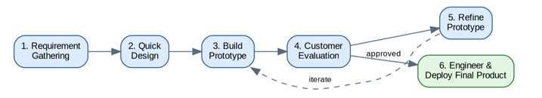

Figure 4.1: Prototyping Model

4.1 Requirement Identification

Requirements were identified by analyzing the shortcomings of existing Nepali hardware retail websites, and by considering the distinct needs of the three user roles the platform must support: customers who search and buy, vendors who list and fulfil products, and administrators who oversee the marketplace.
4.1.1 Requirement Analysis
Requirement analysis shaped the core parts of Circuit Bazaar, including product cataloging, multi-vendor management, cart and order handling, payment integration, and security. Requirements are grouped below into functional and non-functional categories.

4.1.2 Functional Requirements
Functional requirements describe what the system should do, including its inputs, outputs, and interactions.
- User Registration & Authentication: Users can register and log in as a Customer, Vendor, or Admin with role-based access control.
- Vendor & Product Management: Vendors can register their stores and add, edit, or remove product listings with structured specifications, prices, stock information, and product images.
- Search & Filter: Customers can search for products and filter results based on category, brand, price range, and technical specifications.
- Cart & Checkout: Users can add products to a shopping cart, update quantities, and complete the checkout process by providing shipping details and selecting a payment method.
- Payment Processing: The system supports secure online payment through payment gateways such as eSewa and Khalti, as well as Cash on Delivery (COD).
Order Tracking: Customers can track the status of their orders from placement to delivery, while vendors can update order fulfillment status.
- Reviews & Ratings: Customers can submit ratings and reviews for purchased products to help other buyers make informed decisions.
- Admin Management: Administrators can verify or suspend vendor accounts, manage product categories, monitor users, and generate sales reports.

4.1.3 Non-Functional Requirements
Non-functional requirements describe the quality attributes and performance characteristics of the system.
- Usability: The system should provide a clean, user-friendly, and specification-focused interface that is easy to navigate for both technical and non-technical users.
- Performance: Product browsing, searching, and page loading should be completed within a few seconds under normal operating conditions.
- Security: User passwords should be securely hashed, API access should be protected through token-based authentication, and payment information should never be stored in plain text.
- Scalability: The system should support the growth of product catalogs, vendors, customers, and transactions without requiring significant changes to the system architecture.
- Responsiveness: The application should function efficiently across desktops, tablets, and mobile devices, providing a consistent user experience on different screen sizes.
Figure 4.2: Use Case Diagram

4.2 Feasibility Study
A feasibility study is an essential early step in project planning. It evaluates whether a project is practical and achievable by comparing costs, resources, and expected benefits. It focuses on technical, economic, and operational factors to ensure the project is viable and positioned for success.
• Technical Feasibility: Circuit Bazaar uses widely adopted, well-documented, open-source technologies—Next.js, Laravel, and MySQL. These technologies are freely available and have strong community support, making the technical implementation realistic within the project's academic timeline.
• Economic Feasibility: Since the core technology stack is open source, there are no software licensing costs during development. The primary expenses are limited to web hosting, domain registration, and payment of gateway transaction fees. Potential revenue can be generated through vendor commissions, featured product listings, or promotional advertisements.
• Operational Feasibility: The platform is designed with a user-friendly interface, allowing vendors with limited technical knowledge to register stores, manage products, and process orders efficiently. Customers can easily browse, search, and purchase products without requiring specialized training.
• Schedule Feasibility: The project is planned over a 8-week development schedule, as illustrated in the Gantt chart. The timeline includes project planning, requirement analysis, system design, implementation, testing, documentation, deployment, and final presentation, ensuring that all project objectives are completed within the allocated time-frame.

4.2.1 Gantt Chart
Figure 4.3: Gantt Chart

4.3 High-Level Design
Circuit Bazaar follows a decoupled front-end/back-end architecture. The technology choices for each layer are summarized below.
- Frontend — Next.js (React): server-side rendering and static generation for fast, SEO-friendly product pages, with Tailwind CSS for a responsive, mobile-first storefront.
- Backend — Laravel: a REST API built with Laravel's Eloquent ORM, handling authentication (Laravel Sanctum), product/catalog logic, orders, and payment-gateway callbacks.
- Database — MySQL: A relational database for storing users, vendors, products, carts, orders, payments, and reviews.
- Version Control — Git/GitHub: Used to track changes and coordinate collaborative development across the team.
- Diagramming — Graphviz/Draw.io: used to produce the architecture, use case, class, and flowchart diagrams in this proposal.

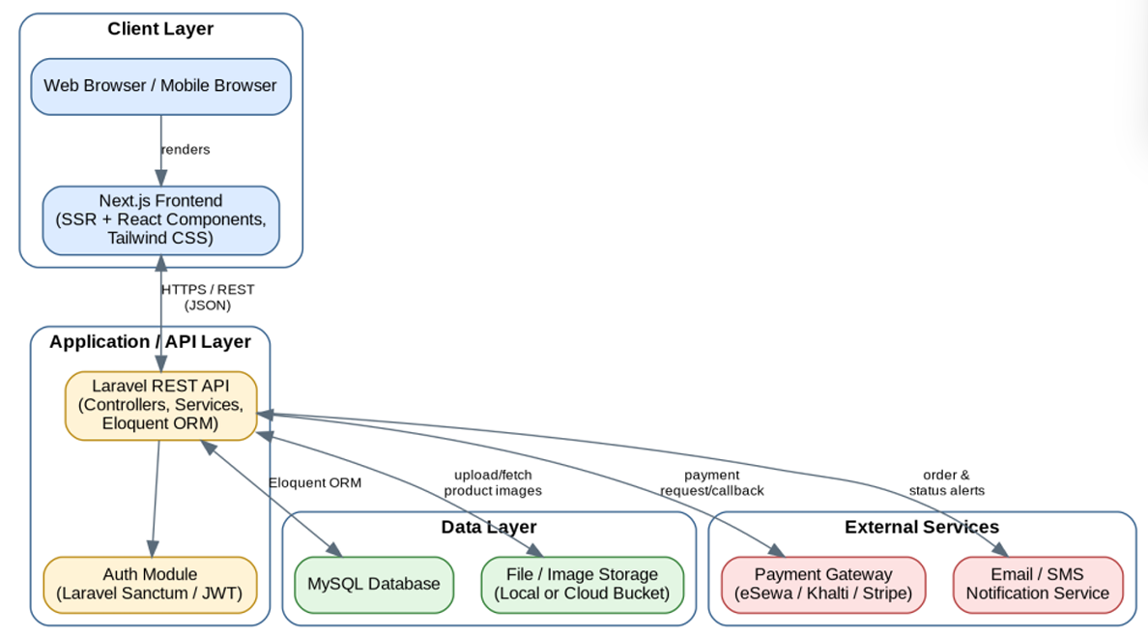

Figure 4.4: System Architecture

4.3.1 Flowchart
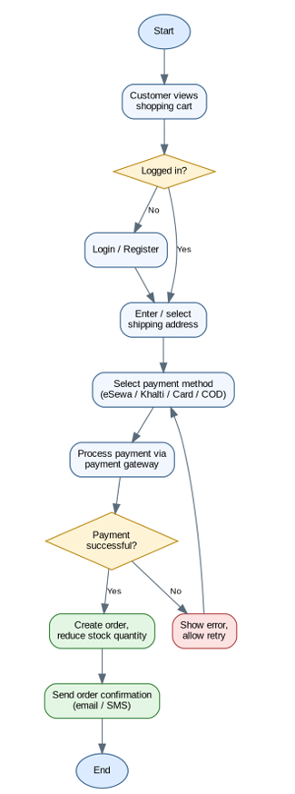

Figure 4.5: Flowchart
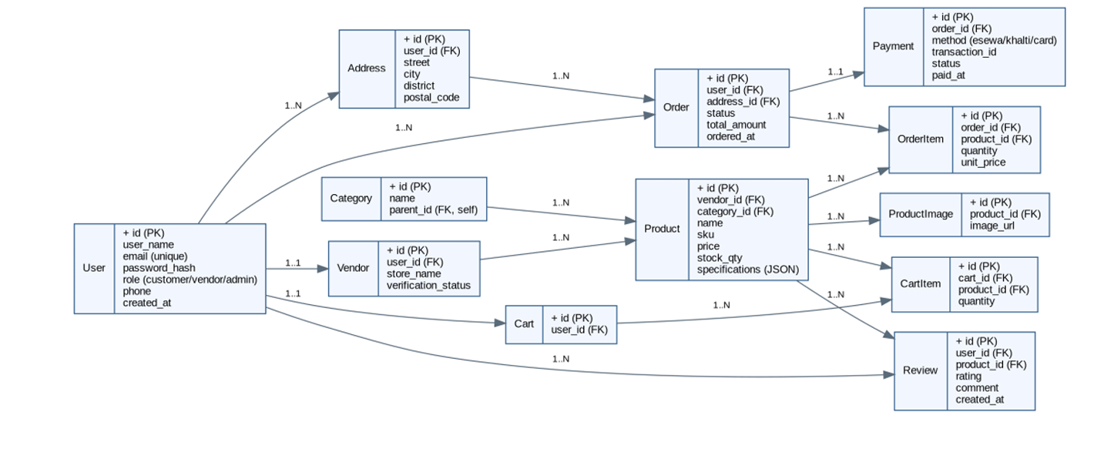
Figure 4.6: Class Diagram

4.4 Description of Algorithms
Algorithms are structured methods that guide how to solve problems or complete tasks efficiently. The following algorithms support the core functionality of Circuit Bazaar:
• Specification-Based Filtering: Products are filtered using a rule-based matching approach against structured specification fields (e.g., socket type, interface, and voltage). This ensures that only compatible electronic components are displayed to customers.
• Sorting Algorithm — Quick Sort: Search results are sorted by relevance, price, or customer rating using a Quick Sort–based approach, allowing users to view the most relevant products first.
• Searching Algorithm — Indexed/Linear Search: Product searches are performed by scanning indexed product fields based on keywords, categories, and filter criteria, enabling efficient and accurate search results.
• Pagination Algorithm: Large product catalogs are divided into fixed-size pages (e.g., 20 products per page), improving system performance and providing a better browsing experience.
• Stock & Order Consistency: When a customer places an order, the product stock is updated within a database transaction. If the payment fails, the transaction is rolled back to prevent incorrect stock updates and overselling.

5. Conclusion
The opportunity for Circuit Bazaar in the online hardware space of Nepal comes from an unmet demand: a store focused on serving the unique requirements of IT and hardware product consumers and professionals. Hardware purchase typically relies on specifications, and the platform has been built to serve exactly those needs and not simply treated as one other commodity available in a large, mixed online market. Using Next.js to power the user interface with the speed and security it offers and a well-secured Laravel-powered REST API built on a MySQL relational database, the team behind Circuit Bazaar strives to create a smooth shopping experience for the end consumer while enabling local hardware stores to join an online platform that serves them well.

6. Expected Outcomes
The Circuit Bazaar project aims to deliver a complete, working web-based marketplace for IT and electronics hardware. The main expected outcomes are:
• A fully operational and responsive multi-vendor marketplace for IT and electronic hardware that is accessible through a web browser.
• Secure, role-based authentication for customers, vendors, and administrators to ensure authorized access and data security.
• Specification-based search and filtering that helps customers find compatible hardware components accurately and efficiently.
• A complete shopping experience, including cart management, secure checkout, integrated payment gateway, and order tracking.
• An administrative dashboard for vendor verification, product category management, order monitoring, and sales reporting.
• A scalable database design capable of supporting additional vendors, products, and categories as the platform grows.

References:
[1] J. B. Sri, N. V. Madhuri, M. Harshavardhan, et al., "Ecommerce Website for Electronic Components – ElectroMart," International Journal for Research in Applied Science and Engineering Technology, vol. 14, no. 4, Apr. 2026, doi: 10.22214/IJRASET.2026.77554.
[2] N. Jha and S. Barthwal, "Key Factors in Online Purchase of Electronic Goods Through Direct-To-Customer Model: A Bibliometric Analysis From B2B and B2C Customer Perspective," Academy of Marketing Studies Journal, vol. 29, no. 6, 2025.
[3] M. S. Mahitharini and J. Hariharan, "E-Commerce Recommendation System," International Journal of Science, Engineering and Technology, vol. 13, no. 2, 2025.
[4] Daraz Nepal, "Online Shopping in Nepal." [Online]. https://www.daraz.com.np
[5] Robu.in, "Electronics, Arduino and Robotics Store.". https://robu.in
[6]DigiKey Electronics, "Electronic Components Distributor.". https://www.digikey.com

